uArm-Firmware Guidance

 | Firmware 3.2 | Firmware 4.3
Description | Old Version Firmware | Add port automatic identification, fix some bugs
Blockly | √ | √
Control | √ | √
Teach & Play | √ | √
Leap Motion | - | √
Draw/Laser | √ | √
3D Printing | √ | -
APP Control | √ | -
Support  Grove Modules | √ | -

Note: the above conditions based on uArm Studio Version 1.1.20.

Q: How to switch between firmware 3.2.0 and 4.3.0 ?
A: If you want to switch the firmware from 3.2.0 to 4.3.0, simply press the “flash firmware V4.2.1” button, then it will flash automatically, and vice versa.
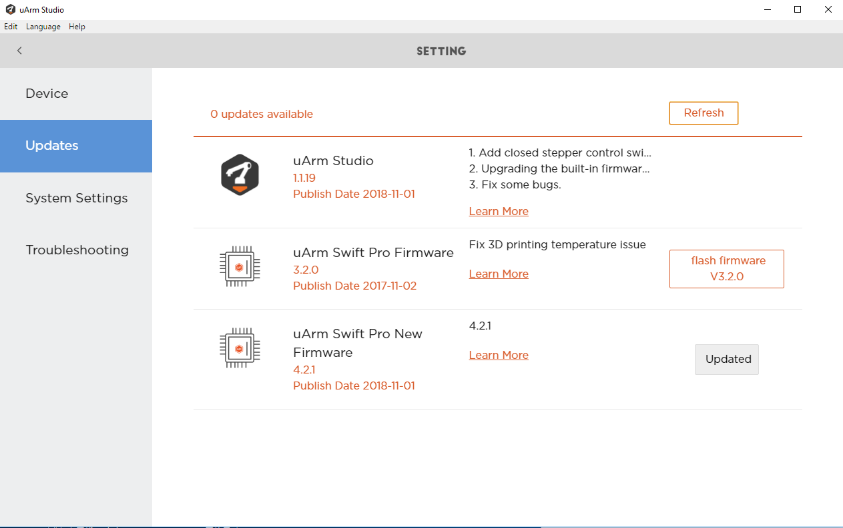

Q: How to use uArm Studio with different firmware?
A: Connect the uArm to your computer, available functions will be shown on uArm Studio automatically.

Q：What firmware is compatible with the vision camera kit?
A：There is a particular firmware for the vision camera kit, please click here to download the file [UArmSwiftPro_2ndUART.hex].

Q：How to flash the vision camera kit firmware?
A：
- Connect the uArm to your computer;
- Download the XLoader and firmware;
- Open XLoader, select the firmware (hex file);
- Click “Device”, select “Mega(ATMEGA2560)”;
- Click “COM port”, select port (the port is different for each computer, please open the “Device Manager” and check the “Ports(COM&LPT)” beforehand);
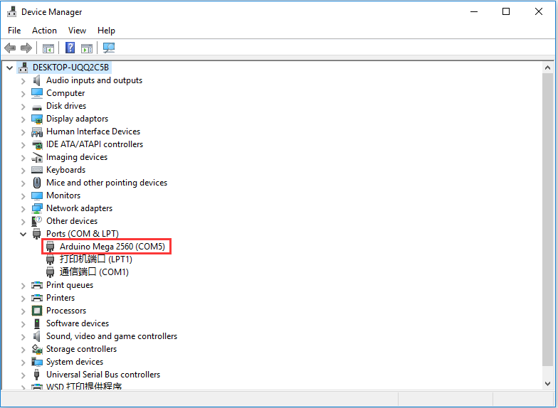
- Set “Baud rate” as 115200; Click “Upload” to finish the flashing process.
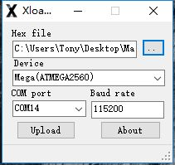

Note: Before you use xLoader to flash the firmware, please make sure you check the following steps:
1) Firstly, turn off the software (e.g. Arduino IDE and/or uArm Studio);
2) After that, enter into “Task Manager” (Ctrl+Shift+Esc), and turn off the “uarmcore”.

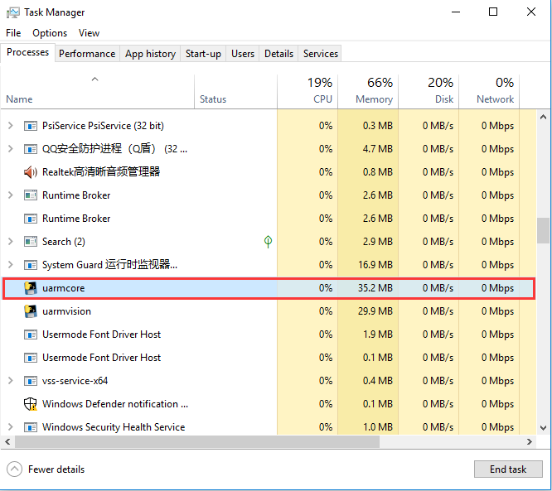

Q: How to download a single file from Github?
A: Please refer to the following link.

